Name:- Gunjal Om Santosh , Roll No:-2541010 , Project Title:- Online Quiz Management System

ONLINE QUIZ MANAGEMENT SYSTEM

1. PROJECT TITLE

Online Quiz Management System

2. PROJECT DESCRIPTION

The Online Quiz Management System is a C programming–based project that allows users to participate in quizzes, answer multiple-choice questions, and view their scores instantly. This project aims to create an interactive quiz platform that tests a user’s knowledge on various topics while also providing immediate feedback.

3. RESEARCH & BACKGROUND STUDY

Traditional quizzes are usually conducted manually, which is time-consuming and prone to errors. By using C programming, we can automate the quiz process and make it efficient.

|  |  |  |
| --- | --- | --- |
| Criteria | Manual Quiz | Online Quiz System (C Program) |
| Time Required | High | Low (automated) |
| Error Chances | More | Minimal |
| Result Generation | Manual & Delayed | Automatic & Instant |
| Engagement Level | Moderate | High (interactive) |
| Data Storage | Paper-based | File Handling (C Program) |

**3.1Flow Chart:**

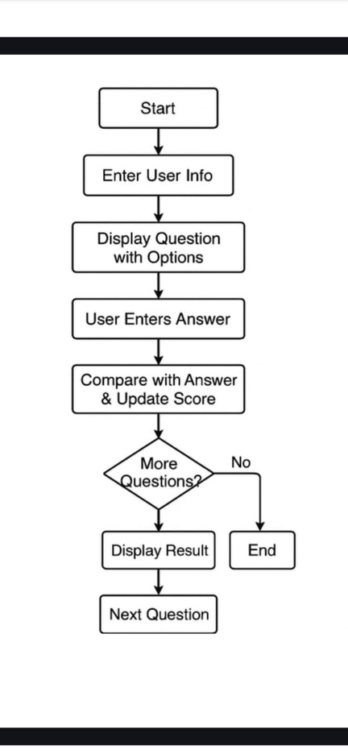

Features Comparison:

4. SYSTEM DESIGN & IMPLEMENTATION

System Design:- Input: User details (name, roll number) and quiz answers.- Process: Program reads questions, compares answers, and calculates scores.- Output: Final score and feedback.

System Modules:

|  |  |
| --- | --- |
| Module Name | Description |
| Login Module | Takes user details (Name, Roll Number). |
| Quiz Module | Displays questions and options to the user. |
| Evaluation Module | Compares user answers with correct answers. |
| Result Module | Displays final score and performance feedback. |

4.1.C PROGRAM CODE

#include <stdio.h>

#include <stdlib.h>

#include <string.h>

void startQuiz();

int askQuestion(char *question, char *options[], int correctOption);

int main() {

char name[50];

int rollNo;

printf("====================================\n");

printf(" ONLINE QUIZ MANAGEMENT SYSTEM \n");

printf("====================================\n");

printf("\nEnter your Name: ");

fgets(name, sizeof(name), stdin);

name[strcspn(name, "\n")] = '\0';

printf("Enter your Roll Number: ");

scanf("%d", &rollNo);

printf("\nWelcome %s (Roll No: %d)!\n", name, rollNo);

printf("Let's begin the Quiz...\n\n");

startQuiz();

return 0;

}

void startQuiz() {

int score = 0;

char *options1[] = {"C Language", "Java", "Python", "HTML"};

char *options2[] = {"Dennis Ritchie", "James Gosling", "Guido van Rossum", "Bjarne Stroustrup"};

char *options3[] = {"1995", "1972", "1980", "2000"};

char *options4[] = {"Portable", "Slow", "Complex", "None"};

char *options5[] = {"Stack", "Heap", "Queue", "Array"};

score += askQuestion("1. Which is the mother language of programming?", options1, 1);

score += askQuestion("2. Who is the father of C Language?", options2, 1);

score += askQuestion("3. In which year was C developed?", options3, 2);

score += askQuestion("4. Which is a feature of C language?", options4, 1);

score += askQuestion("5. Which data structure works on LIFO?", options5, 1);

printf("\nYour Score: %d out of 5\n", score);

}

int askQuestion(char *question, char *options[], int correctOption) {

int choice;

printf("%s\n", question);

for(int i = 0; i < 4; i++) {

printf("%d. %s\n", i+1, options[i]);

}

printf("Enter your choice (1-4): ");

scanf("%d", &choice);

if(choice == correctOption) {

printf("Correct!\n\n");

return 1;

} else {

printf("Wrong! Correct Answer is: %s\n\n", options[correctOption-1]);

return 0;

}

}

4.3. output

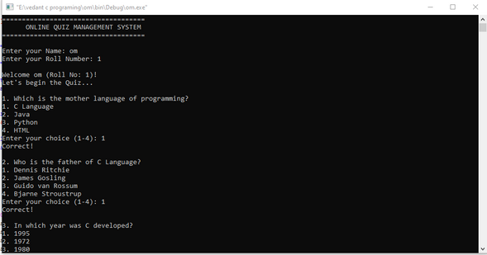

**Processing**

1. Program Starts

Displays the heading “ONLINE QUIZ MANAGEMENT SYSTEM”.

2. User Registration

Takes the user’s Name and Roll Number as input.

Greets the user with a welcome message.

3. Quiz Initialization

The function startQuiz() is called.

Score is set to 0 initially.

4. Question Display

Each question is shown one by one with 4 options.

User chooses an answer by entering a number (1–4).

5. Answer Checking

The program compares the chosen answer with the correct option.

If correct → Adds 1 point to score and prints “Correct!”.

If wrong → Prints “Wrong!” and also shows the correct answer.

6. Repeat for All Questions

The above steps continue until all 5 questions are answered.

7. Result Calculation

At the end, the program prints the final score out of 5.

8. End of Quiz

Program execution ends after displaying results.

Implementation:

1. Header Files Used

#include <stdio.h> → For input and output functions.

#include <stdlib.h> → For general utility functions.

#include <string.h> → For string handling (like removing \n from name).

2. Main Function

Takes user input (Name and Roll Number).

Prints a welcome message.

Calls startQuiz() function to begin the quiz.

3. startQuiz() Function

Initializes score = 0.

Stores multiple choice questions and options in arrays.

Calls askQuestion() for each question.

Collects marks returned from each question and adds to total score.

Displays final score after all questions are answered.

4. askQuestion() Function

Displays a single question with 4 options.

Takes user’s choice as input.

Compares user’s choice with correct option.

Returns 1 if correct, 0 if wrong (this value is added to score).

Prints whether the answer was correct or wrong, and if wrong, shows the correct answer.

5. Program Output

Shows heading, user details, quiz questions, correctness of each answer, and final score.

5. TESTING & RESULTS

The project was tested with different sets of inputs.

Test Cases:

|  |  |  |  |  |
| --- | --- | --- | --- | --- |
| Test Case ID | Input | Expected Output | Actual Output | Status |
| TC1 | All answers correct | 100% Score | 100% Score | Pass |
| TC2 | Some answers wrong | Score calculated accordingly | Correct Score | Pass |
| TC3 | Invalid input (5 instead of 1–4) | Re-prompt for valid input | Works fine | Pass |
| TC4 | No answers attempted | Score = 0 | Score = 0 | Pass |

6. CONCLUSION & FUTURE ENHANCEMENTS

Conclusion:The Online Quiz Management System successfully automates quiz-taking and evaluation using C programming. It provides an engaging and efficient platform for both students and educators.Future Enhancements:- Adding different quiz categories (e.g., GK, Science, Programming).- Implementing a timer for each question.- Storing user performance in a database.- Enabling multi-user participation and leaderboard ranking.